Predicting permanent foreign labor certification decisions from historical data
Data preparation and exploratory data analysis
Daniel Wade Hatcher
Central Michigan university 19 February 2019

Introduction
Hiring foreign workers for employment in the United States is a complex process which normally requires approval from several government agencies. For the employer, the first step in the process is acquiring a foreign labor certification (FLC) from the Department of Labor (DOL). Once certified, the employer has 180 days to petition the Department of Homeland Security’s U.S. Citizen and Immigration Services (USCIS) for a visa. The details of the application process for an FLC depend on the type of visa being requested, but the major steps (shown in Figure #) are the same for all visa types.
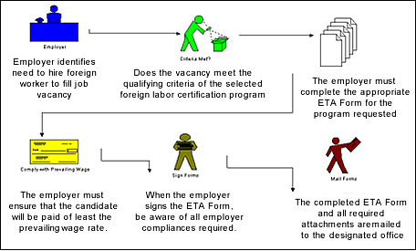
  - Figure #. Major steps in the FLC application process. Note that it is the employer, not the prospective employee, who completes the FLC application. Source: U.S. Department of Labor
Applications for foreign labor certifications are adjudicated by the Office of Foreign Labor Certification (OFLC). OFLC has two application processing centers: one in Chicago for temporary, non-immigrant applications, and one in Atlanta for permanent applications. The National Prevailing Wage Center (NPWC) in Washington, DC processes requests for prevailing wage determinations (PWDs).

Permanent labor certifications
This report will focus on applications for permanent foreign labor certifications. As shown in Figure #, applications for permanent FLCs make up a small but significant fraction of all FLC applications processed – 14% per year on average.

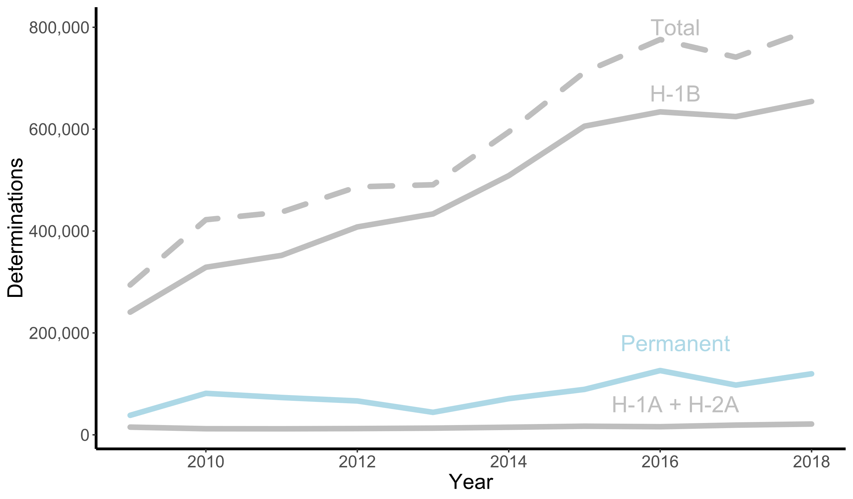
  - Figure #. Number of applications processed annually by type. Applications for permanent FLCs make up a small but significant fraction of all FLC applications processed – 14% per year on average. Data from the Office of Foreign Labor Certification.
As of March 28, 2005, employers wishing to obtain permanent FLCs must complete Employee Training and Administration (ETA) Form 9089. This form describes the job duties; lists the educational, experience, and training requirements; and outlines the foreign worker’s qualifications. Before completing ETA Form 9089, the employer must obtain a PWD and recruit potential U.S. employees. If, among other things, the employer rejects all U.S. applicants and commits to pay the foreign worker at least the prevailing wage, they may apply for a permanent FLC. If the application is certified, the usual next step is filing USCIS Form I-140, Immigrant Petition for Alien Worker.

Motivation for a predictive model
Applying for a permanent foreign labor certification can take months or years. Additionally, the complexity of the application process leads many employers to retain immigration attorneys for their labor certification cases. From a cursory inspection, the average immigration attorney’s fee for a permanent labor certification case is around $6,000, although this is highly dependent on the individual case. For these and other reasons, some employers will no longer consider applicants who require foreign labor certifications and visas – especially if the applicant is entering the workforce for the first time.
The expense of a permanent labor certification application, both in time and money, provides some motivation for a model that could predict the application outcome. This model could be of great use to employers, job-seekers, law firms, and recruiters. In the remainder of this report I will describe the data I believe could be used to build such a model, and the steps I have taken to prepare that data for model building.

Data sources
At the end of each federal fiscal year (October 1 – September 30), OFLC discloses data for each certification type via the OFLC Performance Data webpage. The data is anonymized and only available for applications that were processed during the corresponding fiscal year. The disclosure data for adjudicated permanent FLC applications is composed of 125 variables extracted from ETA Form 9089. The 125-variable datasets are only available for the past four fiscal year cycles (FY2015-FY2018). Data from FY2008 – FY2014 is also available on the OFLC Performance Data webpage but contains only 25 variables covering employer location and prevailing wage. Equally sparse datasets are available for FY2000 – FY2007 on the older FLC Data Center webpage. Only data FY2015 – FY2018 will be used.
The disclosure data from FY2015-FY2018 contains determinations for 432,821 permanent FLC applications. The variable I will use as the prediction target, application decision, can take one of four values: “Certified”, “Denied”, “Certified-Expired”, or “Withdrawn.” The “Certified-Expired” value represents an application that was certified by OFLC but not used to petition USCIS for a visa. The “Withdrawn” value represents an application that was submitted by the employer but withdrawn before the application could be adjudicated. As shown in Figure #, the frequency of denials (dark blue) is relatively stable with an average of 5.7% of applications denied per year.
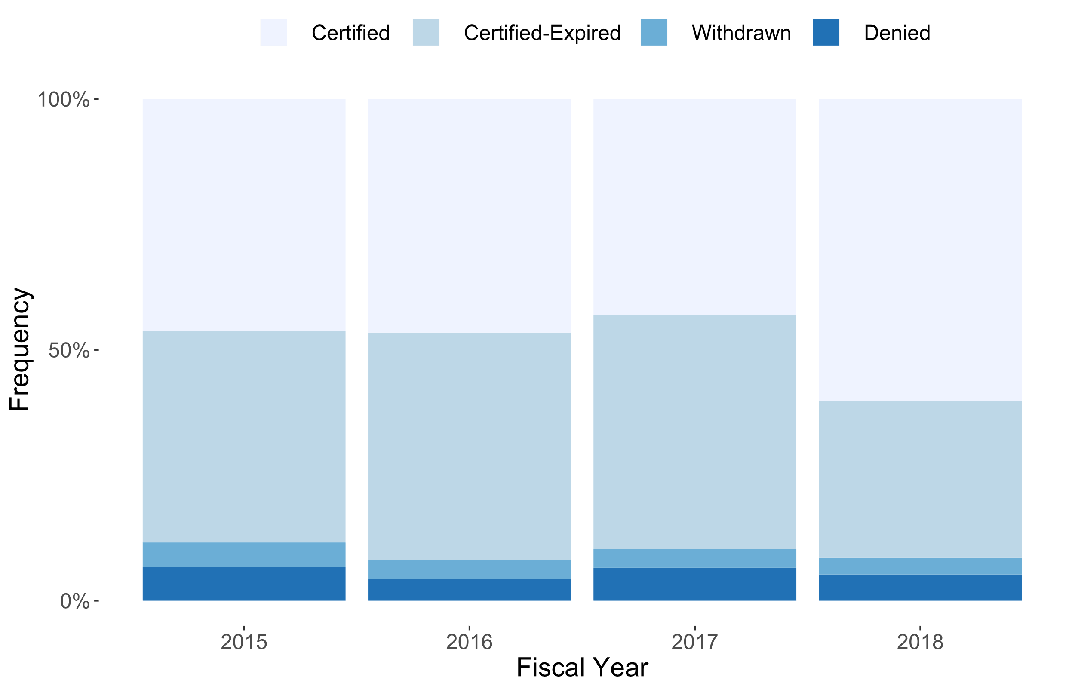
Figure #. Fraction of permanent FLC applications certified, withdrawn, and denied for the period FY2015 – FY2018. The frequency of denials (dark blue) is relatively stable with an average of 5.7% of applications denied per year.

Data cleaning and transformation
Although these four datasets contained information sourced from the same document and compiled by the same entity, they were not immediately ready to be merged and used to build a predictive model.

Exploratory data analysis

Modeling proposal

https://www.foreignlaborcert.doleta.gov/performancedata.cfm
http://www.flcdatacenter.com/CasePerm.aspx

